Consent and opting out: Managing recipient preferences

Answers to common questions

This resource helps states understand current federal text messaging rules and regulations. States can learn whether, how, and why to obtain consent from text recipients and how to manage recipient preferences and opt-outs. The resource is for state agencies and their staff who plan to or are sending text messages to applicants and/or enrollees.

This playbook is an ongoing effort part of a federal/local texting working group co-hosted by the Aspen Institute’s Financial Security Program and the Facing Financial Shock Life Experience project. We anticipate this playbook to be published in sections. The first sections (below) focus on consent, communication preferences, and opt-out communications.

Each section contains responses to frequently asked questions, clear communication of best practices, and referential resourcesof citations and further examples of these practices might look like in the real world. *Disclaimer: this document contains legal analysis and citations for federal rules and regulations only; senders may have other or more restrictive rules to consider at the state level to consider. You should consult your legal counsel for advice on any legal matter.*

# Getting consent to text for the first time

Obtaining consent is a critical step in building trusting relationships and positive communications with the public. Consent is when a recipient understands and gives permission to a sender to contact them via text messaging.

## How and when do we need consent to text our customers?

Federal and State governments may send text messages without consent. According to the FCC, Federal and State governments conducting official business are not subject to the Telephone Consumer Protection Act (TCPA) and can send text messages without obtaining consent.

Generally, the TCPA does apply to counties, cities, and others (e.g. contracted vendors or non-profits), who must have consent to send text messages. However, the inclusion of a phone number on a Medicaid or other government healthcare benefits application constitutes consent to be contacted at that number about that benefit program. The FCC has also stated that a “consumer simply providing their telephone number constitutes their ‘prior express consent’ to be contacted at that number regarding information closely related to the purpose for which they provided the number, absent instructions to the contrary.”

Cell phone companies may require that any sender applying for a sending number (short or long code) demonstrate they obtain consent.

**Best practice**

It’s considered a best practice to obtain prior express consent from text recipients so that they are aware of and have control over how they are contacted. Consider including a pre-checked plain language opt-in (i.e. “It’s OK to text me.”) on forms, as well as a question about the recipient’s preferred language for text messages. It is also important to include information about standard message and data rates the recipient may incur and how to opt-out of receiving text messages.

One example of pre-checked consent collection comes from the State of Minnesota in partnership with Code for America (CFA) that has increased opt-in rates for text messaging.

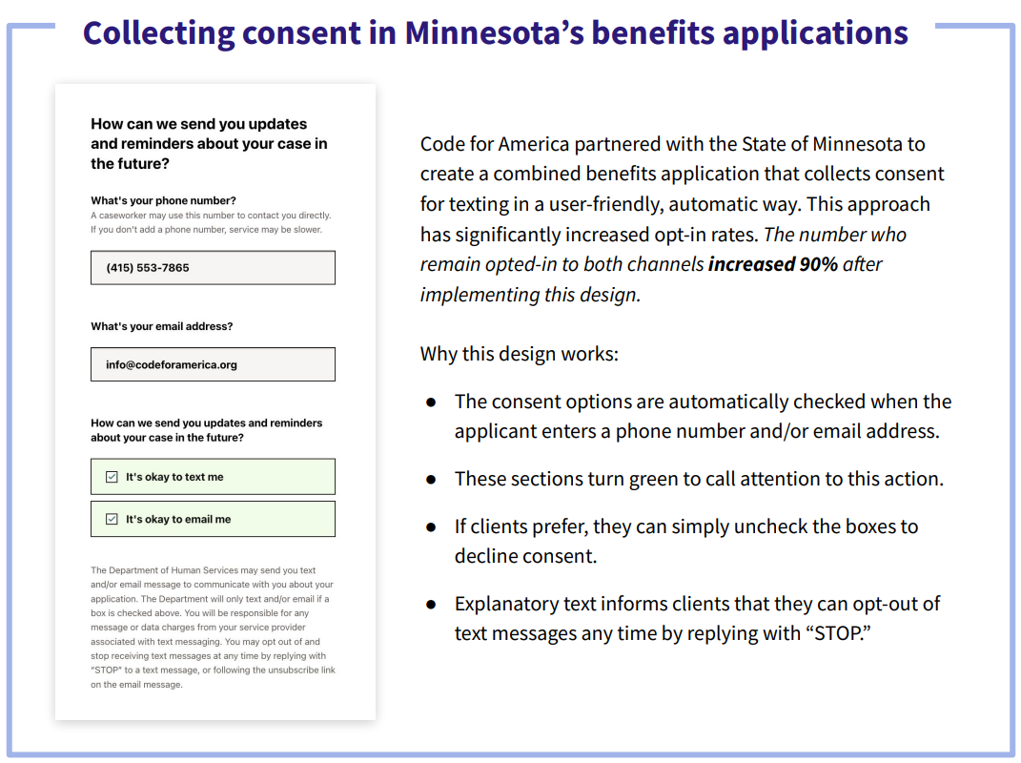

Another example of how to manage recipient opt-ins and preferences is Michigan’s online client portal, which allows users to opt-in to receive text message and/or email communications for different types of notifications.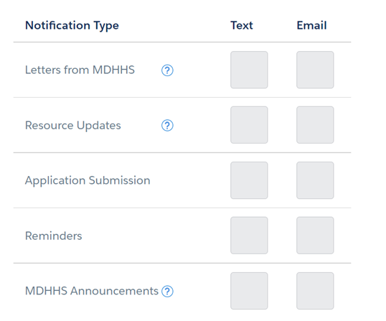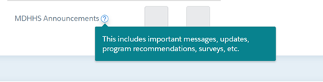

**Policy updates**

The FCC has not ruled on whether providing a phone number on a benefit application constitutes express consent to be contacted at that phone number about additional benefits the applicant may be eligible for.

**References**

[U.S. Department of Health and Human Services Declaratory Ruling, DA–23-62, Docket No. 02-272 (2023).](https://docs.fcc.gov/public/attachments/DA-23-62A1.pdf)

Code for America’s [Texting Playbook: Basics of Texting Safety Net Clients](https://codeforamerica.org/programs/social-safety-net/texting-playbook/) (Available for free download)

# Applying consent and phone number data across programs

Understanding how to reach people who are eligible for multiple programs is important to expanding access. Texting eligible populations is one way to inform them about additional benefits they could receive.

## How can we “inherit” consent from another program and share and receive phone numbers with that program?

The FCC has held that states aren’t subject to the Telephone Consumer Protection Act (TCPA), so states may send text messages without getting explicit consent from users. States using phone numbers to text across benefit programs does not violate the TCPA. However, outside of TCPA, states may also be subject to other federal and/or state regulations depending on the benefits program(s) customers are involved in.

In general, non-state texters can’t share phone numbers across programs (for new outreach or to update contact information) unless sharing permissions are explicitly mentioned during the consent process.

**Best practice**

It’s considered a best practice to include more expansive consent language that permits data sharing and outreach across benefits programs. States should also check all relevant federal and state regulations involving sharing numbers across programs to ensure there are no additional conflicts.

**Examples of outreach and data-sharing across programs**

[BDT and North Carolina example](https://bdtrust.org/medicaid-and-snap-data-coordination-case-studies_north-carolina_march-2023.pdf): Benefits Data Trust (BDT) and the state of North Carolina used texting to notify Medicaid recipients about FNS eligibility. BDT sent text messages and outreach letters to low-income individuals and families (18 years of age or older and receiving Medicare and or Medicaid) who might also be eligible for Food and Nutrition Services. The text messages provided information about how to apply for Food and Nutrition Services benefits and directed recipients to the North Carolina Benefits Center website.

[CBPP and BDT example:](https://www.cbpp.org/research/food-assistance/using-data-matching-and-targeted-outreach-to-enroll-families-with-young) Center on Budget and Policy Priorities (CBPP) and BDT used data-sharing and texting to get “adjunctively eligible” participants from one program enrolled in WIC. CBPP has done multiple pilots since 2018 on this topic in different states. In 2023, BDT conducted data-driven outreach via text messaging on behalf of 8 states and local governments.

The CFA [National Tax Benefits Outreach Campaign](https://codeforamerica.org/programs/tax-benefits/outreach/) worked with 25 state benefits agencies to text clients about the opportunity to claim the Child Tax Credit. CfA sent 10,196,624 messages, with $42,100,055 in benefits claimed as a result. [Their analysis of the effectiveness of different outreach strategies](https://files.codeforamerica.org/2022/03/15163515/lessons-from-simplified-filing-in-2021-getctc-analytics-report-march-2022.pdf) showed that cross-referrals were the most effective way to encourage families to file for the benefit.

Michigan’s DHHS will often send texts on behalf of other agencies to direct recipients to a program or agency that wants to connect. Recently, they sent texts to encourage recipients to subscribe to texts for P-EBT benefits ahead of the benefits going live. To do this, they used the following message:

*The Department of Human Services invites you to get texts with important notices including information about the Pandemic Electronic Benefit Transfer (P-EBT) program. For more information visit mn.gov/dhs/p-ebt. If you do not want to receive messages, reply with STOP*

**References**

[U.S. Department of Health and Human Services Declaratory Ruling, DA–23-62, Docket No. 02-272 (2023).](https://docs.fcc.gov/public/attachments/DA-23-62A1.pdf)

# 

# 

# Validating and updating phone numbers

## Senders must manage the phone number data they have to avoid sending messages to incorrect or old numbers.

## How and when do we ask customers to update their phone numbers and/or communication preferences?

**Best practice: How**

**Use touchpoints**: Ask customers for their current phone number at key service touchpoints (for example, when a customer calls a call center, visits an agency office, completes an application, and so on). If someone initially opted out of texting, consider asking them during the recertification period if they’d like to update their communications preferences. We also recommend using multimodal communication options, which improves the overall customer experience.

**Multi-program notifications or universal profiles**: States can ask individual programs for updated information, but multi-program notifications or universal profiles may be easier to use as a single source of truth.

**Best practice: When**

**Frequency of messages:** There are no specific requirements regarding how often states can ask participants who **aren’t** receiving messages if they’d like to opt into text messaging. There also isn’t any Cellular Telephone Industries Association CTIA guidance.

* Offering opt-in opportunities too frequently or in a high-burden way may annoy people. Benefits recipients may change contact information more frequently than other groups, so it may be prudent to ask for updated information and preferences more frequently than other guidelines (using expansive consent language).

## How and when do we update customers’ numbers in our databases?

As soon as a sender finds out a number they have been using is incorrect, the sender must stop using that number.

There aren’t currently any statutes or regulations that specify how frequently senders should update their phone number database. However, it’s a best practice to ensure senders are using current numbers for all customers.

**Best practice**

According to CTIA guidance, “[m]essage Senders should process telephone deactivation files regularly (e.g., daily) and remove any deactivated telephone numbers from any opt-in lists.” Document any changes to phone numbers with a timestamp.

**References**

[Cellular Telephone Industries Association (CTIA) Guidance](https://api.ctia.org/wp-content/uploads/2019/07/190719-CTIA-Messaging-Principles-and-Best-Practices-FINAL.pdf)

## How can we make sure we have customers' most current phone numbers?

Outside of validating phone numbers directly with customers, staff can query the FCC’s Reassigned Number Database (RND) against their own list. This database contains phone numbers reported by phone carriers as reassigned or disconnected and may provide liability protection in the case of accidentally sending a text message to the wrong person (if the database was also outdated) ([www.Reassigned.us](http://www.reassigned.us)).

Validating against other available data sources is also acceptable.

**Best practice**

Query the RND to identify numbers that have been reassigned from previous consumers – this will protect against inadvertently contacting the wrong people. Use timestamps to ensure use of customers’ most current numbers.

**References**

Public Benefits Studio (General Services Administration): [Directions for using RND to test existing data set](https://drive.google.com/file/d/1Eb2ltfnI_CLsuTxkRiiFVgoVleFRmnuf/view?usp=drive_link)

# Opt-out & post-opt-out communications

When someone no longer wants to receive text messages from a sender, they can opt out of receiving text messages. To “opt out” means to revoke one’s consent to receive text messages.

## What are recipients’ rights around opting out of text communications?

Revoking consent: In February, 2024 the FCC adopted new requirements around revoking consent. The new rules state that these requirements only apply to texts where consent is required under the TCPA. The new rules lay out that a user can revoke consent by using words like “STOP," "QUIT,” “END,” “REVOKE,” “OPT OUT,” “CANCEL,” or “UNSUBSCRIBE” or other phrases that that clearly express they do not want to receive more texts.

Additional ways to revoke consent: Some text senders don’t allow users to send reply texts. If a sender doesn’t allow reply texts, they must do the following:

* Let the user know that two-way texting isn’t available
* Provide another way for the user to revoke consent (this method needs to be described clearly)

Some reasonable alternative methods of revoking consent include a user leaving a voicemail or emailing the sender. For text senders who rely on consent, it is important to have procedures in place to catch and process revocation of consent requests that are made using these alternative methods.

Honoring requests: The FCC also amended existing regulations to require that text senders honor company-specific do-not-call and revocation of consent requests as soon as possible (and no more than 10 business days after a user revokes consent).

One follow-up: Finally, the FCC stated that a one-time text confirming a text recipient’s request that no further messages be sent is permitted under the TCPA as long as the confirmation meets these criteria:

* It confirms the opt-out request
* It doesn’t include marketing or promotional information
* It’s the only additional message sent

The sender’s confirmation message must be sent within 5 minutes of the opt-out text to be covered under the original prior express consent.

Continued attempts to text a number that has opted out is a violation of the TCPA and can impact deliverability and harm the sending number’s reputation score.

**Best practice**

When someone opts-out of receiving text messages, remove their phone number from any future text communications as soon as possible or within 24 hours. It’s a best practice to do this even if the sender is a state and did not need consent in the first place. Senders may send a one-time text message confirming the opt-out request and may wish to clarify the scope of the opt-out request in that message - we describe best practices for requesting clarification of which messages a recipient no longer wishes to receive in the following two sections.

**References**

[TCPA Omnibus Declaratory Ruling and Order, 30 FCC Rcd 7961 (2015)](https://docs.fcc.gov/public/attachments/FCC-15-72A1.pdf)

[Rules and Regulations Implementing the Telephone Consumer Protection Act of 1991, Order, FCC 24-24, (2024](https://www.fcc.gov/document/fcc-adopts-rules-empower-consumers-stop-robocalls-robotexts-0))

## How do we make it clear what a recipient is opt-ing out of (e.g. all communications vs. specific communications)?

Senders may text a request for clarification of the scope of revocation, as long as the sender ceases all future texts (unless the recipient indicates that they’d like to receive future texts).

In February, 2024 the FCC codified the rules around confirming a text recipient's opt-out request. These rules also apply only to text messages that require consent under the TCPA. Text senders may request clarification of the opt-out request in the one-time confirmation text discussed above, as long as the text sender ceases all further texts absent an affirmative response from the text recipient. This rule has several caveats:

1) It is limited to situations where the text recipient has consented to several categories of text messages from the sender;

2) If the sender does not receive a response from the text recipient, the recipient’s opt-out must be treated as a revocation of consent for *all* texts from the sender;

3) The confirmation text must not contain any marketing, advertising, or any content to persuade the text recipient to reconsider their opt-out decision.

**Best practice**

A texting pilot launched via a partnership between the state of Connecticut and Code for America used nuanced opt-out texts (such as “STOP” for general opt out and “OptOutSNAP” for opt out for SNAP-related messages only) that gave recipients the option of opting out of individual text messaging campaigns, rather than opting out of texts from the state agency altogether. The pilot texted 148,371 unique numbers; 597 opted out, which translates to a 0.4% opt-out rate.

Twilio also provides step-by-step guidance on how to implement “advanced opt-out" to allow senders to customize opt-out messaging and keywords.

**References**

[Soundbite Communications Inc. Declaratory Ruling, FCC-12-143, CG Docket No. 02-278.](https://docs.fcc.gov/public/attachments/FCC-12-143A1.pdf)

Code for America and Connecticut Texting Example: [Shoulder to Shoulder: Building Trustworthy Communication between Government and the Clients It Serves](https://codeforamerica.org/news/shoulder-to-shoulder-connecticut/)

[Twilio: Getting Started with Advanced Opt-Out](https://support.twilio.com/hc/en-us/articles/360034798533-Getting-Started-with-Advanced-Opt-Out-for-Messaging-Services)

[Rules and Regulations Implementing the Telephone Consumer Protection Act of 1991, Order, FCC 24-24, (2024)](https://www.fcc.gov/document/fcc-adopts-rules-empower-consumers-stop-robocalls-robotexts-0)

## What are we allowed to send after someone opts out?

For texts that require consent under the TCPA, senders may send a one-time text message confirming the opt-out request. See the above discussion on the February, 2024 FCC Order.

For texts that require consent under the TCPA, senders may text a request for clarification of the scope of revocation within that one-time follow up message. See the above discussion on the February, 2024 FCC Order.

**Best practice**

For senders who do not rely on text message consent under the TCPA, after a recipient texts STOP to opt out of receiving messages, senders might consider messaging one follow-up text that includes the following information:

1) Numbered reply options listing reasons a customer chose to opt out: *wrong number*, *not interested in program*, *not interested in any texts*, and so on.

2) Instructions on how to resume receiving messages: “To re-enroll in text messages, …”

Regardless of the type of sender, ensuring recipients can learn about options to enroll in text messaging through a variety of channels is recommended. Upstream awareness and ease of enrolling will help to ensure text options are available to all potential recipients if they later decide to change their mind or re-enroll.

**Reference**

[Soundbite Communications Inc. Declaratory Ruling, FCC-12-143, CG Docket No. 02-278.](https://docs.fcc.gov/public/attachments/FCC-12-143A1.pdf)

[Rules and Regulations Implementing the Telephone Consumer Protection Act of 1991, Order, FCC 24-24, (2024)](https://www.fcc.gov/document/fcc-adopts-rules-empower-consumers-stop-robocalls-robotexts-0)